ST JOHN’S SCHOOL UNIFORM POLICY

RATIONALE
The wearing of a school uniform at St John’s encourages the development of a strong sense of identity, both within the school and in the wider community. It encourages a sense of equality and of personal dignity.

VALUES
The values to which this policy witnesses include those of justice, equality, a sense of community and commitment to the school. The policy also fosters the values of reverence, respect, dignity and self-worth for all students.

POLICY STATEMENT
Parents are required to ensure that their children wear the prescribed uniform at all times while their children are at school or involved in school-related activities.

CONSEQUENCES
- Children are encouraged to have respect for, and pride in, their personal appearance.
- Parents are responsible for ensuring that the school uniform is maintained in good condition for the duration of the school year.
- Parents may have input into any proposed uniform changes by bringing the matter to a meeting of the P & F Association.
- Details of the prescribed school uniform are available at the time of initial enrolment and at the beginning of each subsequent year.
- Items of new clothing that are specific to St John’s are available through the school.
- A second-hand clothing shop operates during the school year.
- Where there is financial difficulty for parents in providing the prescribed school uniform, parents are invited to discuss practical assistance with the principal.
- Parents of children who repeatedly depart from wearing the prescribed uniform will be contacted by the principal.

Reviewed – 2015; Current as of 15/02/18

SPECIFIC REQUIREMENTS

DAILY (DRESS) UNIFORM: Available for the St John’s Uniform Shop
- Girls:
  - Blouse – White and royal blue checked polycotton. Button up with royal blue rounded collar and sleeve trim. Elbow length sleeves. Princess line over-blouse forming 2 front peaks on the hip line. School badge is to be worn on the left hand side of uniform.
  - Culotte/Skort – Royal blue culottes (shorts) or royal blue skort.
  - Dress – White and royal blue checked polycotton. Button up with royal blue rounded collar and sleeve trim. Elbow length sleeves. Princess line. School badge is to be worn on the left hand side of uniform.
- Boys:
  - Shirt – White and royal blue checked polycotton. Button up with a royal blue revere collar and sleeve trim. School badge is to be worn on the left hand side of shirt. Shirt to be worn tucked in at all times.
  - Shorts – Royal blue shorts Stubbies or Midford brand are accepted, short or medium length but not below the knee. NO ‘cargo’ or basketball shorts or knit shorts.

SPORT’S UNIFORM: Available for the St John’s Uniform Shop
- Girls and Boys:
  - Unisex Sports Shirt – Vertically multi-striped from left: royal blue/white/royal blue/navy; royal blue sleeves and stripes continue on back. Collar printed with school name, navy tab. Available only from the school uniform shop.
  - Unisex Sports Shorts – Ink in colour. Available only from the school uniform shop.
The sports uniform can be worn twice a week; on the PE lesson days and Tuesday.

HOUSE UNIFORM: Available for the St John’s Uniform Shop
- Girls and Boys:
  - Unisex House Shirt – Green (McAuley) and Gold (O’Connell) polo shirts. Collared with House name embroided on left-side of chest. As per sports uniform; worn tucked in. House shirts are to be worn for House Spirit Days and intra-school sporting carnivals (e.g St John’s athletics and swimming carnivals).

WINTER UNIFORM:
- Girls and Boys: In addition to the daily uniform outlined above, students may wear a plain navy cardigan, navy jumper, navy track suit (all with NO coloured trim or piping) or navy tights. Undershirts are to be white or navy. These items may be purchased through normal retail outlets.

HAIRCUTS:
- Boys and Girls: No colours, perms, streaks, foils, extensions or coloured hair sprays. No tracks. Fringes cut or pinned so that they stay out of eyes.
- Girls only: Hair longer than shoulder length should be tied back. All hair trims must be minimal in size and of school colours only (royal or navy blue or white).
- Boys only: Boys should have neat school boys’ style haircuts. Hair is to be no longer than the collar. Boys are not permitted to have extended hair lengths (e.g. rat tails). Fringe lengths should be cut so that they are out of the eyes. Boys are not permitted to have hair cut shorter than Gauge 2.

ACCESSORIES/jewellery:
- Girls and Boys: A plain chain with Christian symbol/cross/crucifix may be worn by both girls and boys, inside the dress or shirt. No rings. No bracelets. No arm bands (unless for recognition days/ events i.e. National Day of Action Against Bullying, medical reasons, or reasons approved by the principal).
- Girls: Earrings are limited to small traditional gold or silver sleepers or studs (with natural type stones) with only one earring per ear lobe. No makeup or nail polish is to be worn.
- Boys: No piercing is permissible.

SHOES & SOCKS:
All students are to wear black leather or leather look lace up or velcro joggers. There is to be no additional colour on the shoe. The shoe is to be low cut at the ankle. There are to be no volley, Mary-Jane, material/canvas style shoes. White school socks must be worn at all times. The sock must be no more or less than approx. 5 cm above the ankle of the shoe with NO colour visible and NO roll down styles. The correct school sock is available from the school uniform shop.
 | Shoes | Socks
Acceptable | 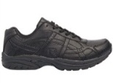  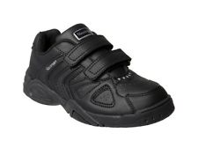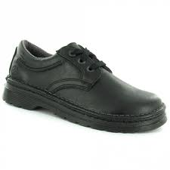 | 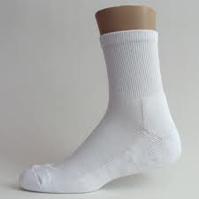
Not Acceptable | 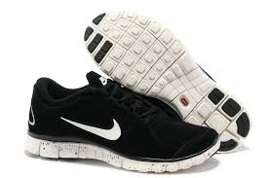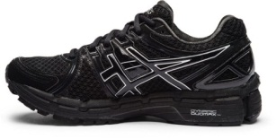  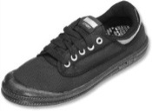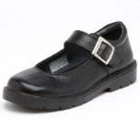 | 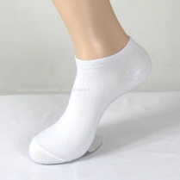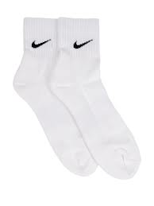

SCHOOL HAT:
Each student must wear the school hat for all outdoor activities at school. No caps are allowed. Variations to this expectation should be accompanied with a note from the child’s parents. In 2016 a new school bucket hat was introduced as a replacement for the previous wide-brimmed hat. Old hats can continue to be worn for 2017, however, the new bucket hat will be the only hat option from Semester 2 2018.

Some parents may choose to have their child(ren)’s hat embroided with their name. Guidelines and expectations for these area:
- Font style: Block upper case lettering in an Arial/Times New Roman style
- Font size: approximately 10mm in height
- Font colour: white
- Position for embroiding: rear of hat on the brim
- Name style: 1 of 2 options – first name & last initial (Mary S); first initial & last name (M Smith).

FREE DRESS:

On occasion the school will hold free dress days. Shirts with sleeves are to be worn in keeping with our Sun Smart policy. Joggers or school shoes are the only permissible shoes. Wide brim/bucket hats are allowed – no caps.

STUDENT LEADER SHIRTS:

Year Six students will have a student leader shirt that they are able to wear. This will be worn on a Friday along with their sports shorts.

OTHER UNIFORM REQUIREMENTS:
Students out of uniform must have an accompanying note of explanation to be presented to the teacher.

Naming of Uniform:
All articles of clothing are to be MARKED CLEARLY.
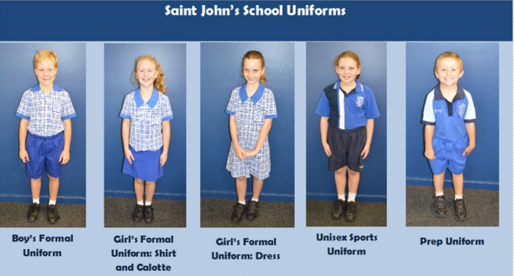

Thursday, 15 February 2018

ADVICE TO PARENTS – INCORRECT STUDENT UNIFORM

Dear _________________

Our school has a very presentable uniform and one that we are very proud of. It is very important to our school community that our presentation remains uniform and that dress does not become a fashion competition.

In most cases, the student’s look terrific in their uniform and are clearly very proud of the way they present themselves. However, there are a small number of children whose uniform does not yet fully comply with our school’s policy and I am seeking your support.

Today during a routine review of uniforms, we noticed that _________ didn’t comply with the requirements in that ____________________________________________________________________
_____________________________________________________________________________________
_____________________________________________________________________________________
____________________________________________________________________________________.
We would be grateful if this could be rectified at your earliest convenience.

I would strongly urge you to check with the school if you have any doubts, because as a parent I am well aware that the opinions of your children, or stories about “what other kids are wearing”, can be misleading and not always accurate or reflect our school guidelines.

I believe that wearing a uniform correctly, reflects both pride in one’s self and in one’s school. We have a commitment to each other to ensure that the uniform is worn correctly. It is also very unfair to the vast majority of children who wear the uniform correctly, to allow others not to comply.

Thank you for your attention to this matter. The support the staff and I receive from parents is tremendous, and it is this ongoing support that allows us to continue to make St John’s a school we can be so very proud of.

If I can be of any help to you in this or any other matter, please contact me.

Kind regards
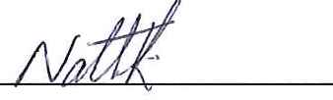
Nathaniel Rice

